Model 5
SHADE AND WATER with independent TABLE TANK
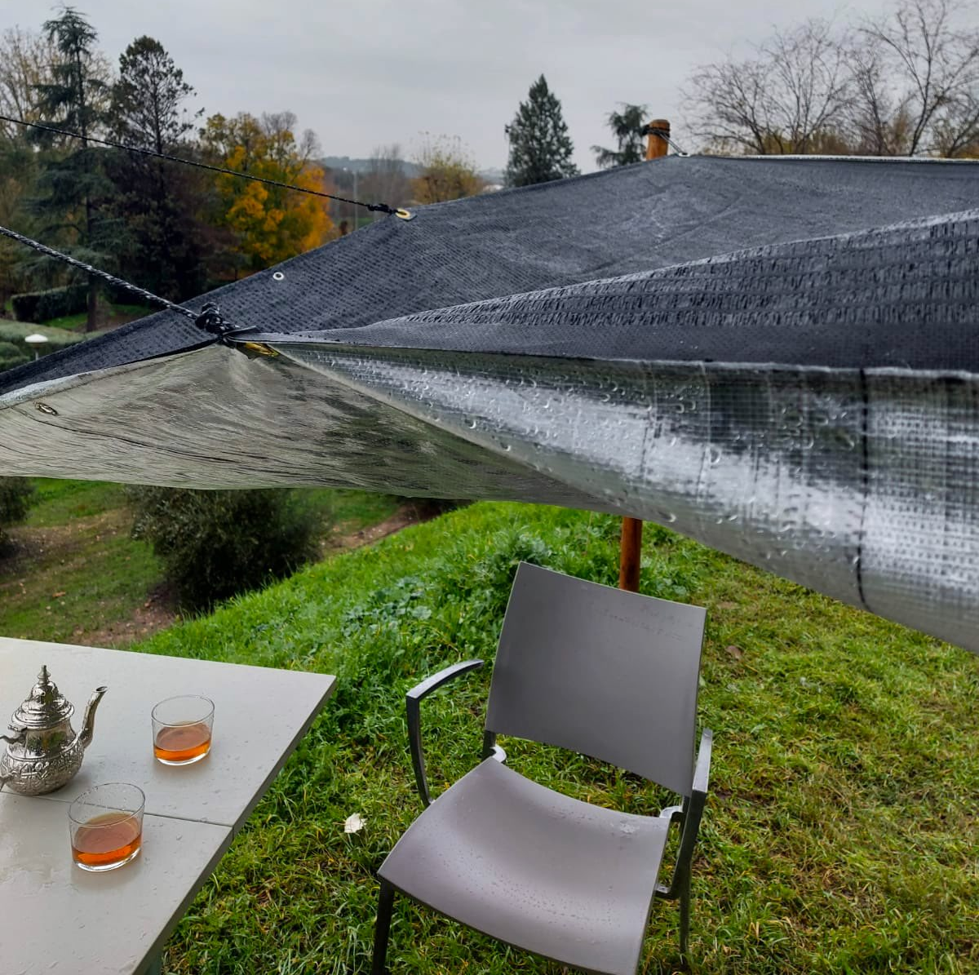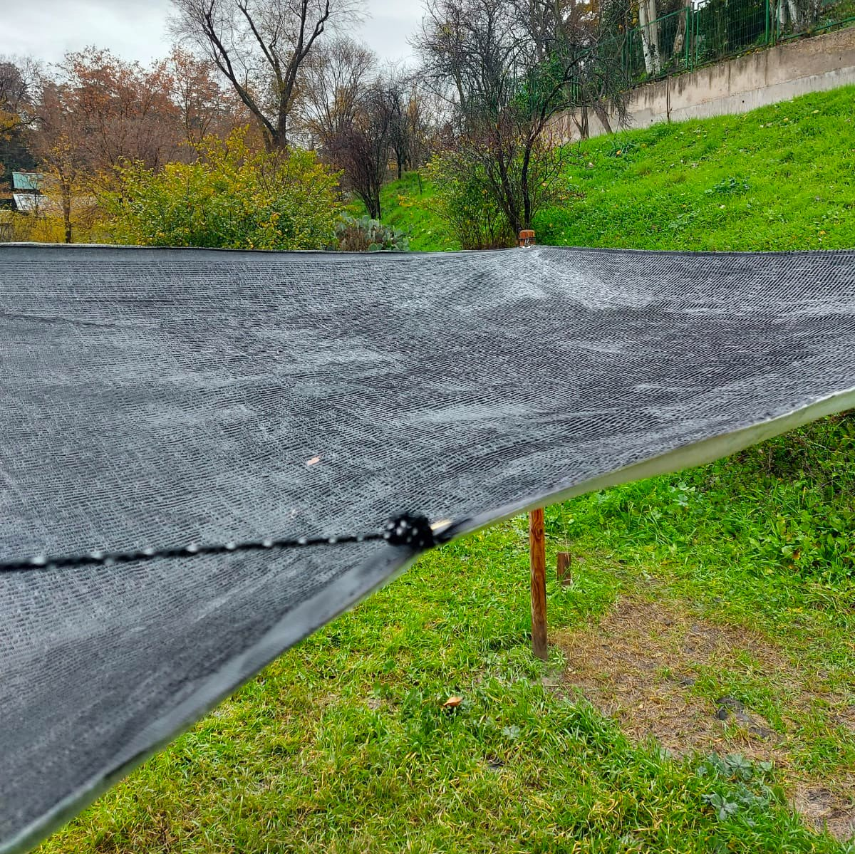
A PLASTICIZED RAFFIA RAIN WATER COLLECTOR SET and black SHADE MESH to avoid the sun.
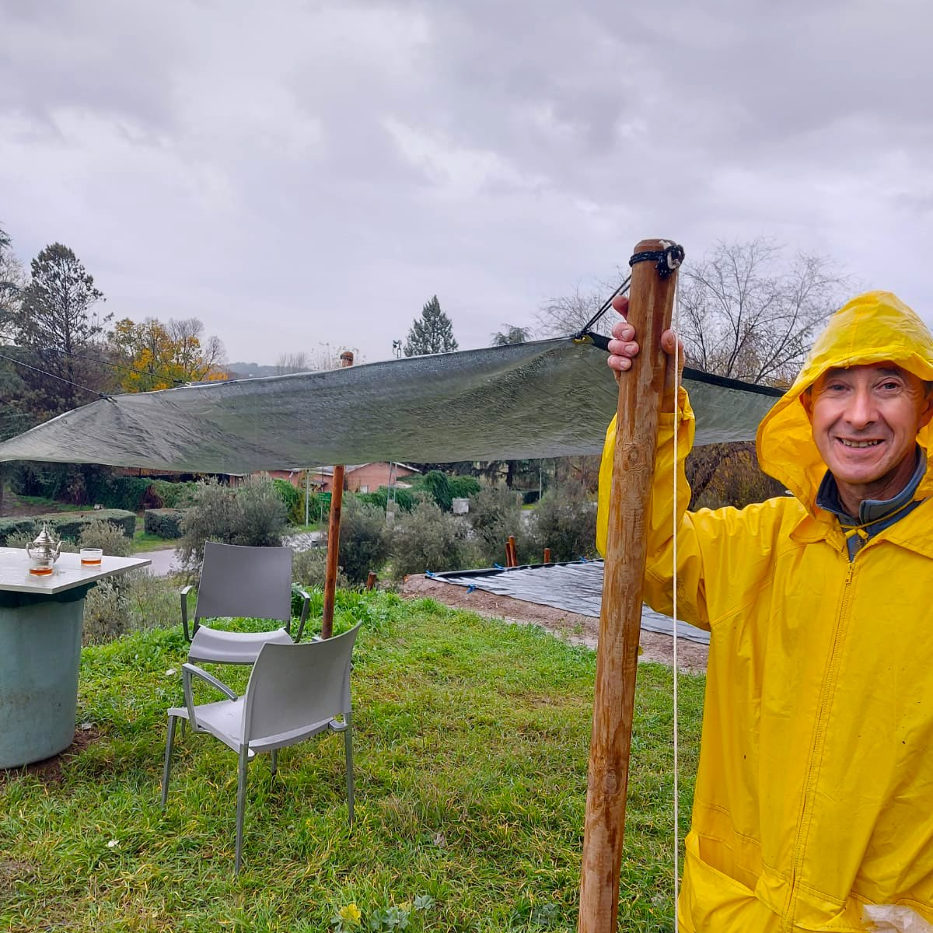
4 WOODEN stakes tightly nailed to the ground hold the SET by tying it to the 4 EYELETS of the corners.
The angle of one of the corners is given a SLOW TILT so that it leads the water to ANY tank.

A 2.6 meter rope is tied in 2 holes separated by 1 meter in a right angle, which HOLDS the stake located in the slope to tighten the set. 2 hooks on that stake prevent the rope from slipping. It also has a 1 meter rope tied to the 2 eyelets in that corner and CLAMPED equally to that stake to better adjust the fall of the water.
The corner eyelets are also tied together with a 10cm rope.
The tank will have a TAP and double FILTER of mesh and fabric to improve the quality of the water.
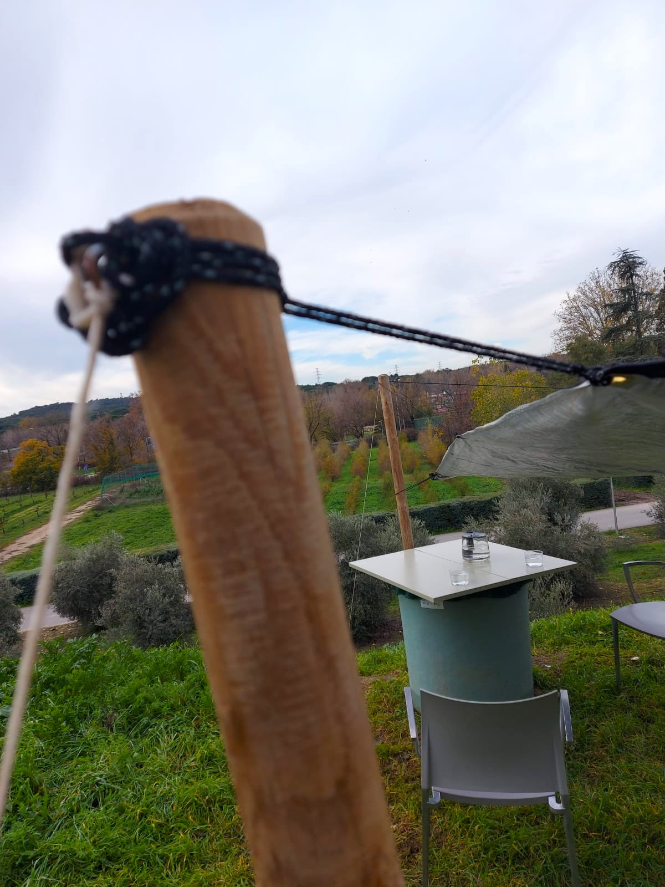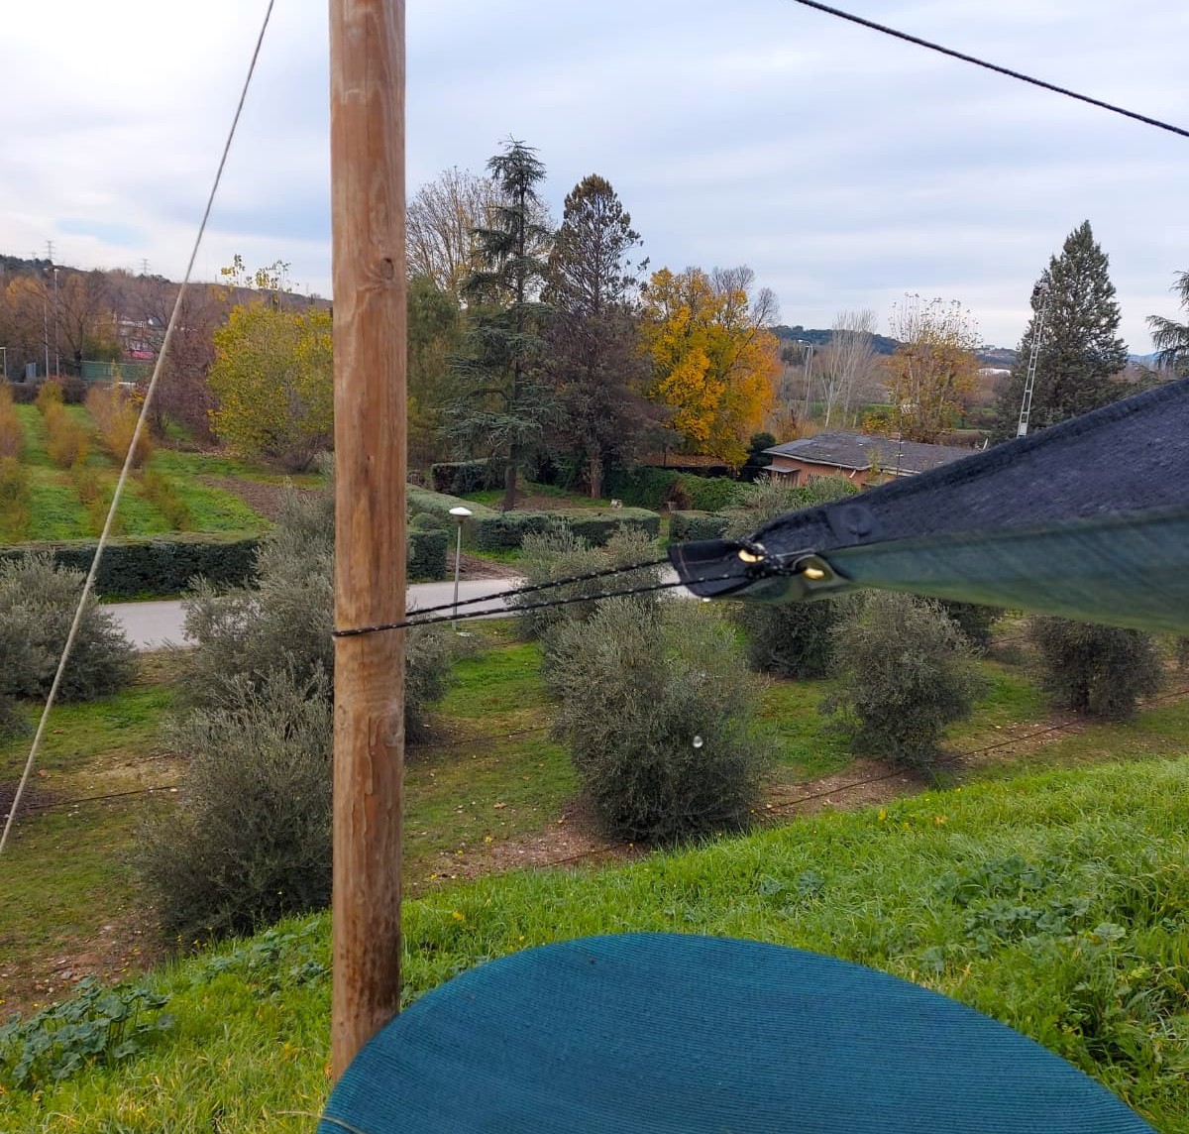
The model can be easily dismantled by untying the ropes on the stakes. When it is windy, the model must be UNTIED.
In addition, if it is windy at the place of use, the stakes MUST be reinforced with 4 winds tied to the ground

POTABILITY, CONSUMPTION AND CONSERVATION OF RAINWATER

Water is LIFE and it is "ALIVE". It requires CARE from the beginning.
Before drinking the water collected directly from the RAIN, you must PURIFY it by means of:

FILTERS
BOILING IT
CHLORINATING IT, if needed

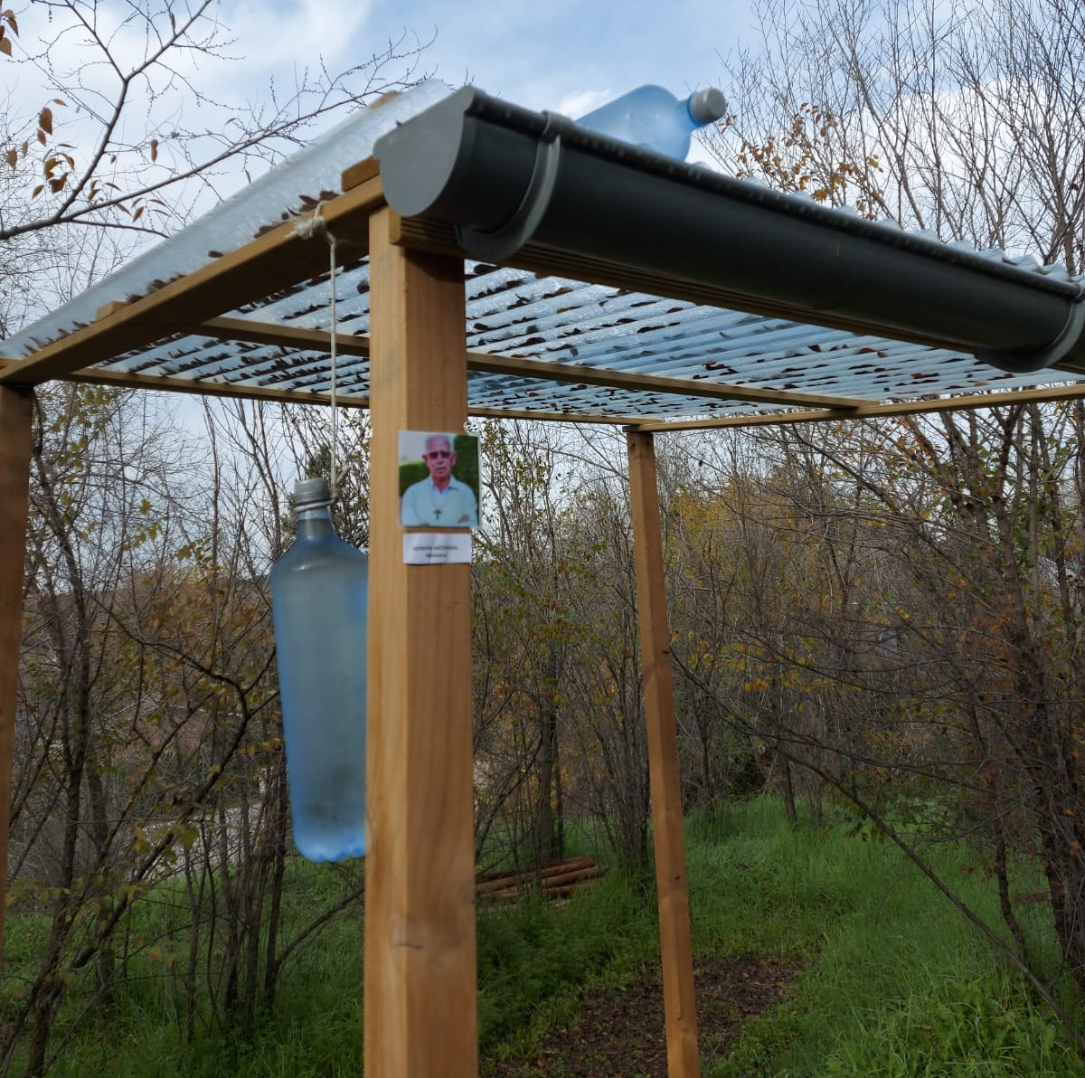
The SODIS method

The SODIS method of natural rainwater purification is simple.
It consists in putting TRANSPARENT PLASTIC BOTTLES in the SUN for:
8 hours if it is sunny or 2 days if it is cloudy.

In addition, we must be careful not to CONTAMINATE the water OURSELVES by:

- Guaranteeing the maximum personal hygiene by means of prior HAND WASHING.
- Using CLEAN pots. If possible, THE SAME.
- NOT MIXING water, even if it is clean, WITH CONTAMINATED FOOD.

OTHER IMPORTANT INFORMATION:

- The POND will always be built with LOCAL WORKFORCE and its installation will be preferably done by the interested parties themselves.
- It is necessary to BUY there:

- The deposit with a TAP. A porous MESH and ANOTHER fabric to tie it covering the deposit.
- The possible board to put on top of the tank as a TABLE
- 4 high wooden stakes. They should be nailed 50 centimeters and reinforced with stones so that they are well fastened.
- 4 small stakes to tie the 4 "winds" of rope tightly. (see photos)

T h e m o d e l INCLUDES:

- The PLASTIC MATERIALS : THE PLASTICIZED RAFFIA AND A SHADING MESH.

- R o p e s.

