Model 4
FAMILY collector with independent tank
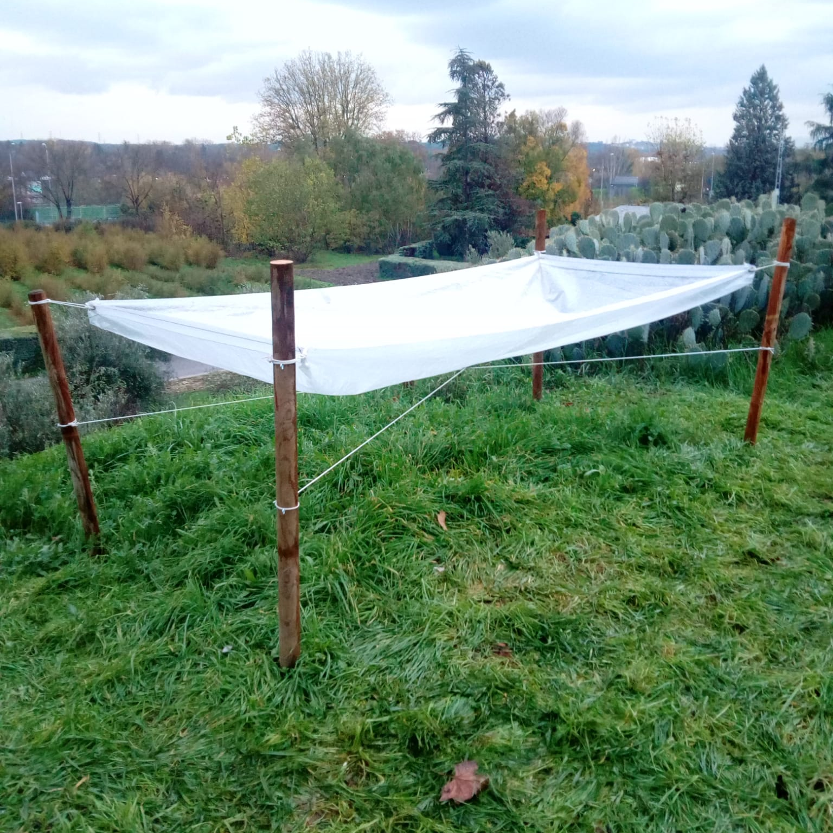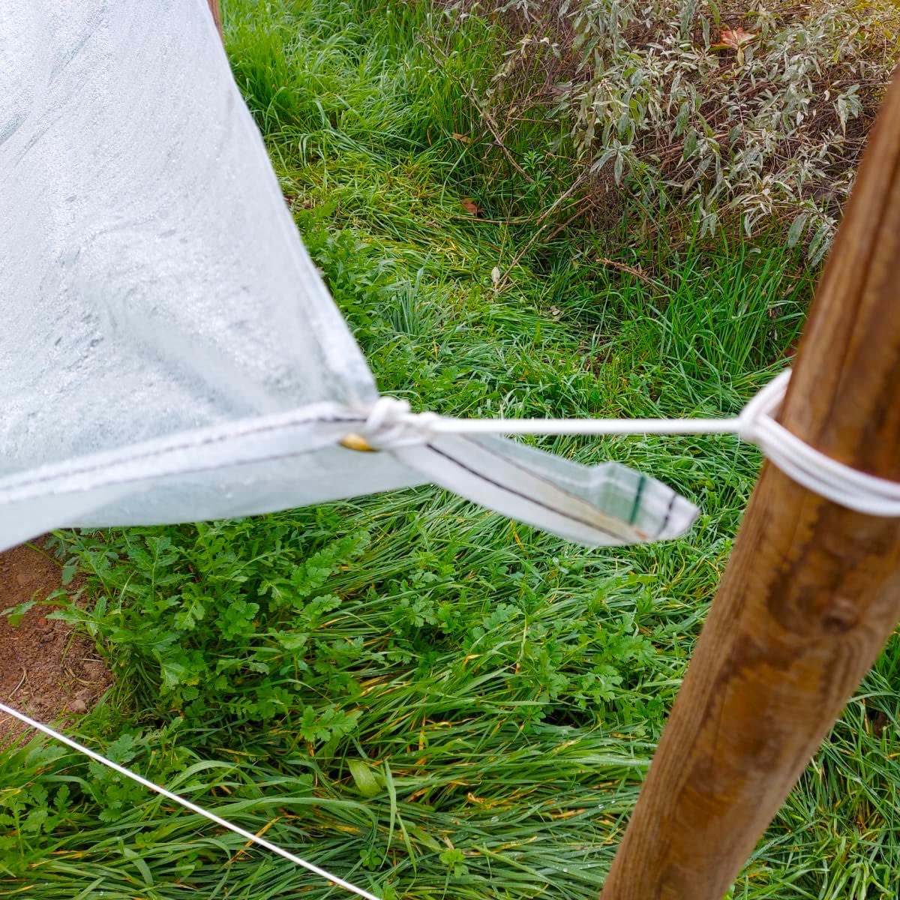
The collector is attached to four WOODEN stakes for fastening.
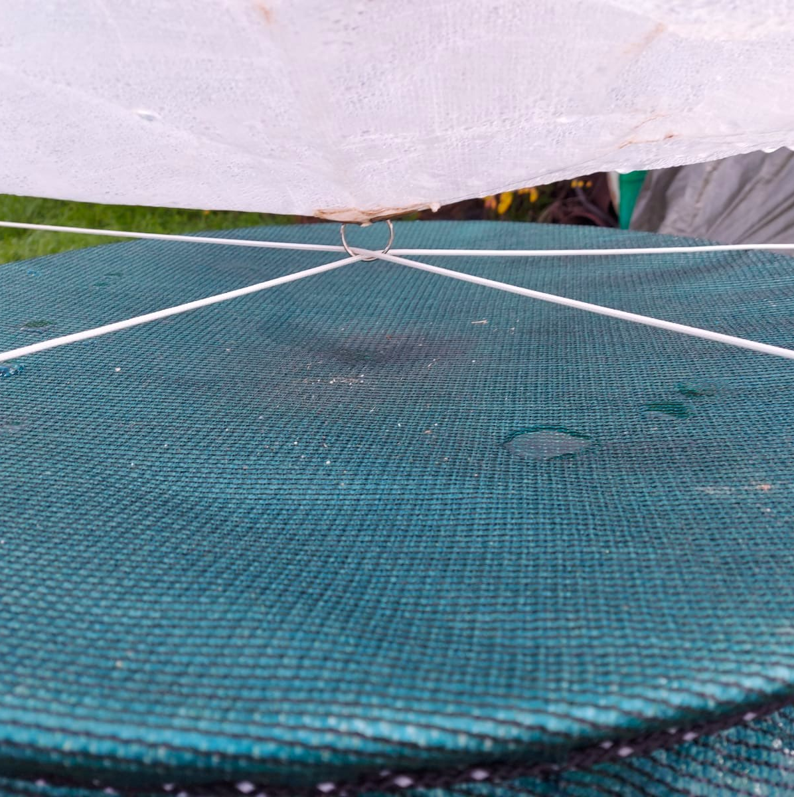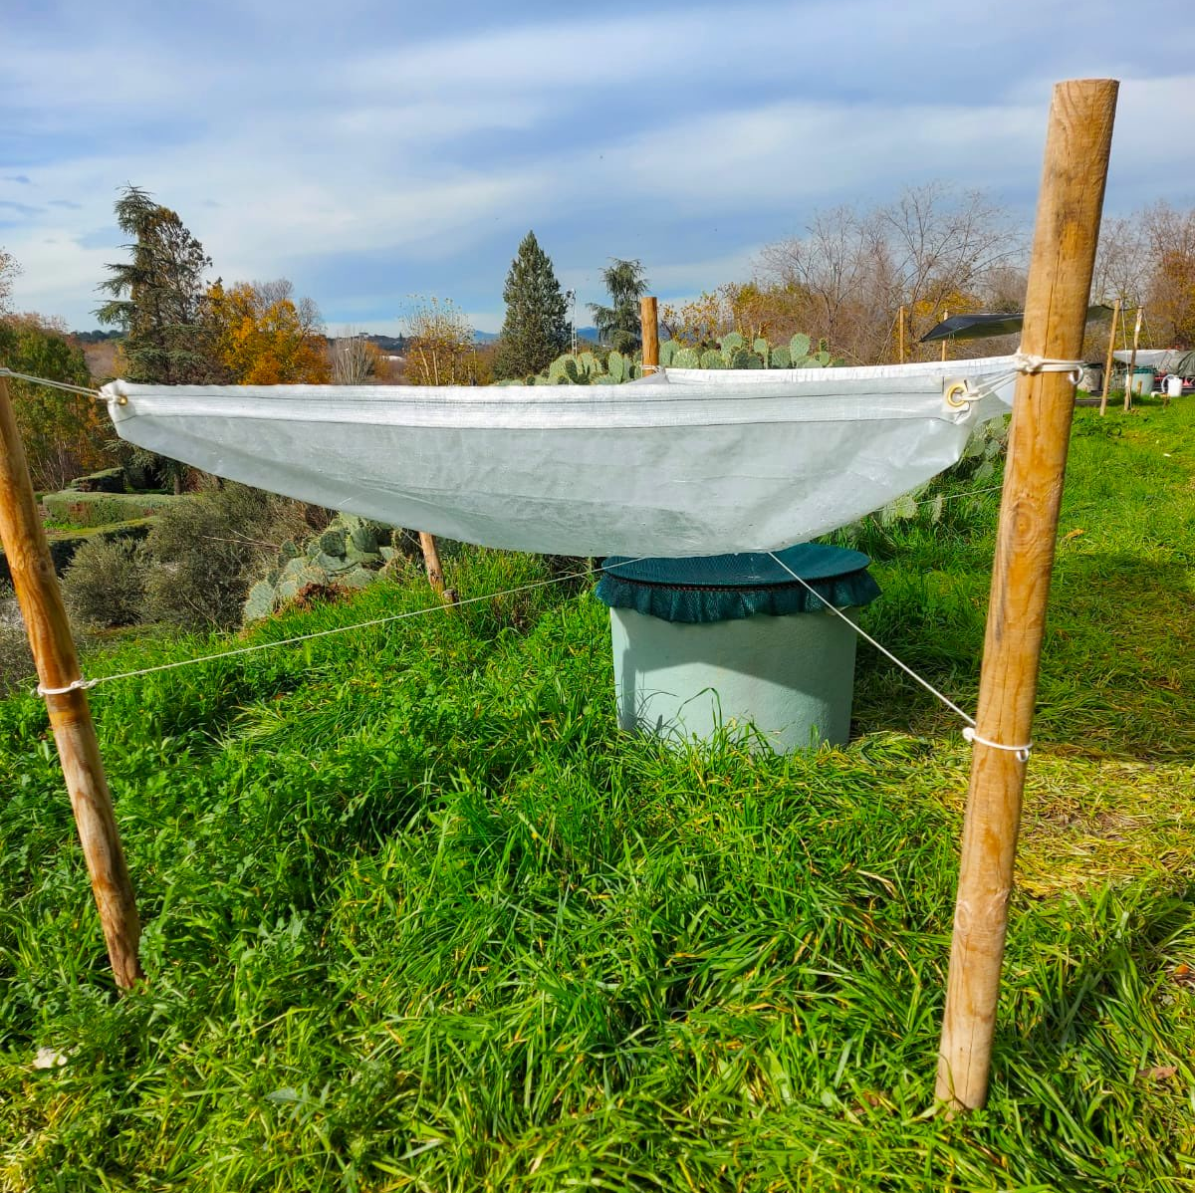
To mitigate the wind, a ring is passed through the two eyelets in the center of the collector and INSIDE the ring, two ropes that embrace the four stakes WITHOUT tying them to it.

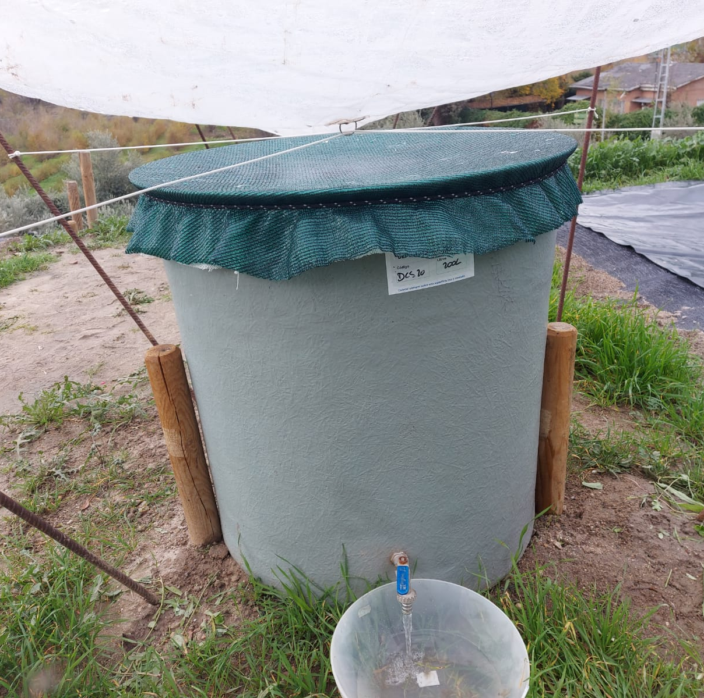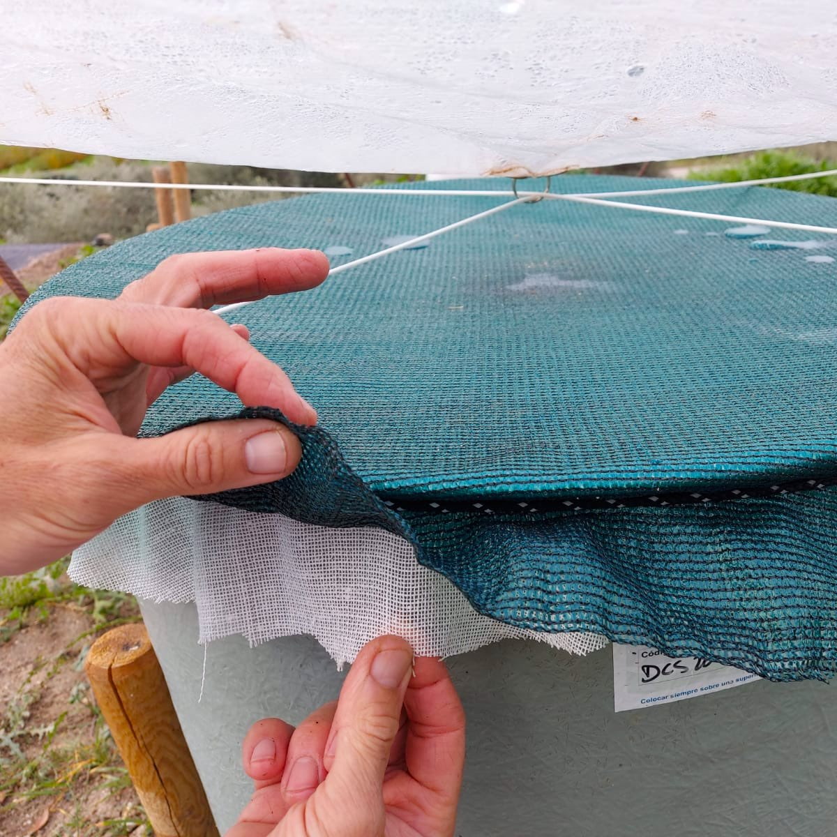
The water falls directly into ANY TANK, which must have a TAP and be protected with a double FILTER of mesh and fabric to improve the purity of the water.

POTABILITY, CONSUMPTION AND CONSERVATION OF RAINWATER

Water is LIFE and it is "ALIVE". It requires CARE from the beginning.
Before drinking the water collected directly from the RAIN, you must PURIFY it by means of:

FILTERS
BOILING IT
CHLORINATING IT, if needed

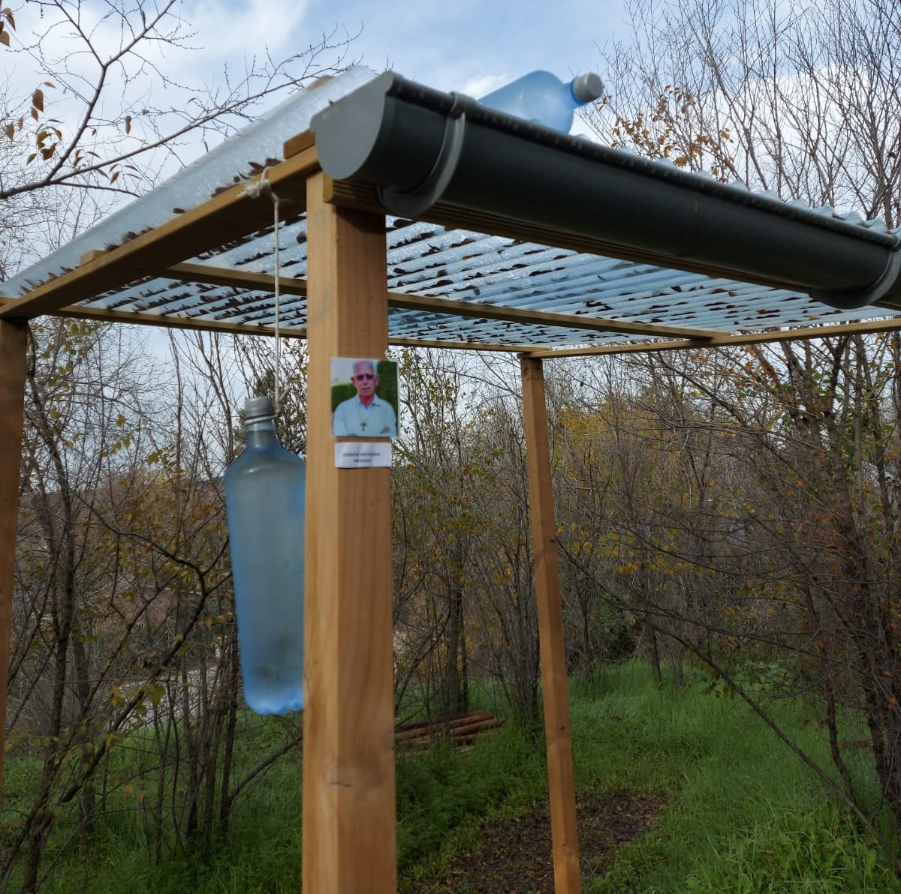
The SODIS method

The SODIS method of natural rainwater purification is simple.
It consists in putting TRANSPARENT PLASTIC BOTTLES in the SUN for:
8 hours if it is sunny or 2 days if it is cloudy.

In addition, we must be careful not to CONTAMINATE the water OURSELVES by:

- Guaranteeing the maximum personal hygiene by means of prior HAND WASHING.
- Using CLEAN pots. If possible, THE SAME.
- NOT MIXING water, even if it is clean, WITH CONTAMINATED FOOD.

OTHER IMPORTANT INFORMATION:

- The POND will always be built with LOCAL WORKFORCE and its installation will be preferably done by the interested parties themselves.
- It is necessary to BUY there:

- - The deposit with a TAP. A porous MESH and ANOTHER fabric to tie it covering the deposit.

- 4 medium height wooden stakes. They should be nailed 40 centimeters and, in addition, reinforce the soil with stones. Make sure they are well fastened and inclined slightly outwards (see photo) to counteract the tight strings

- 2 small stakes to fit the tank.

T h e m o d e l INCLUDES:
- The PLASTIC MATERIAL : PLASTICIZED RAFFIA.
- 6 EYELETS . 4 in the corners and 2 in the center, plus 1 ring where you pass the ropes through.
- R o p e s.

