Model 3
INDIVIDUAL collector linked to AFRICAN DEPOSITS
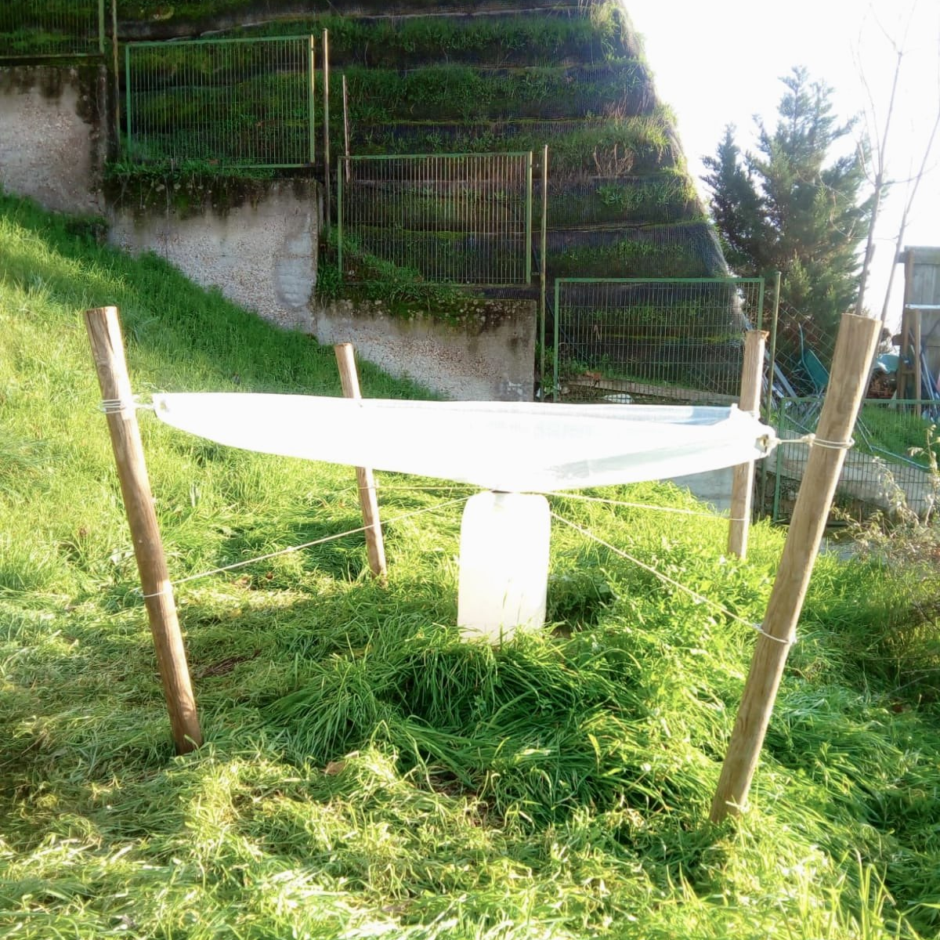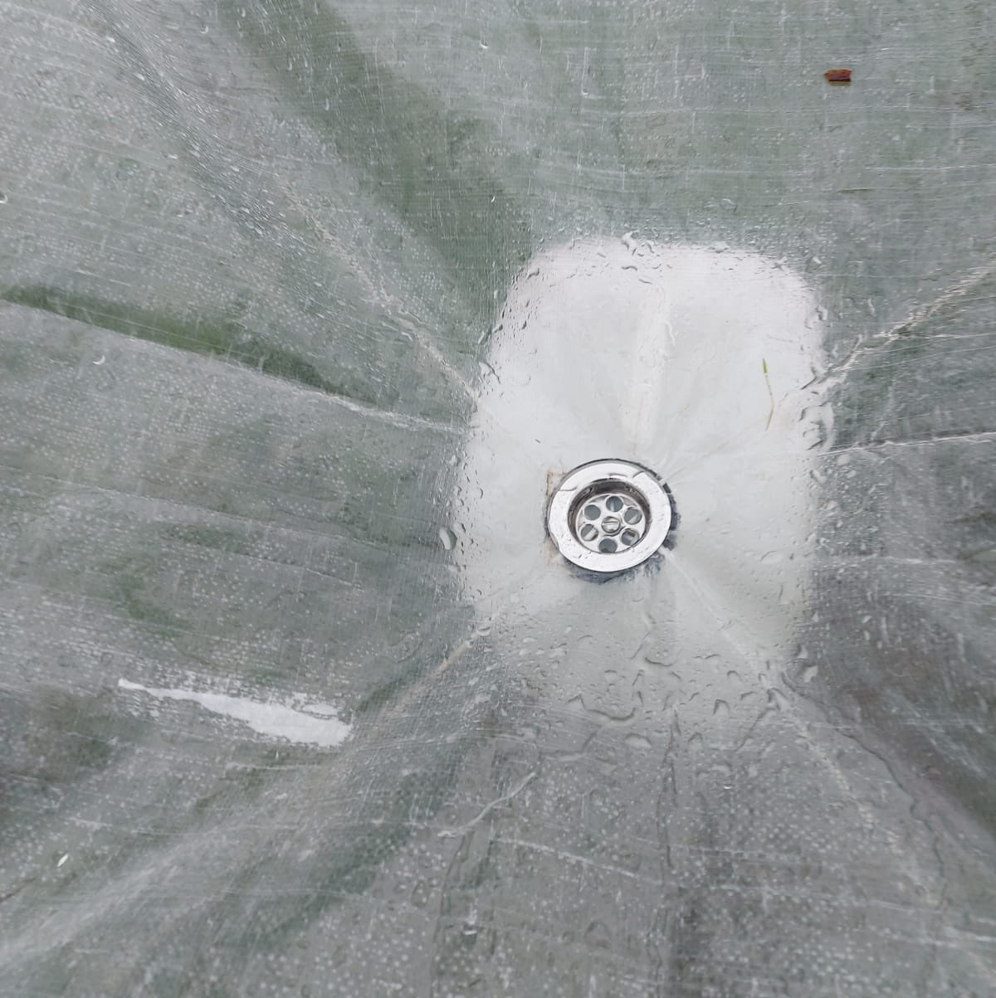
PLASTICIZED raffia collector, with a hole in its center where water is poured directly into portable tanks spread all over Africa.
The collector conducts the water through a DRAIN located in its center.
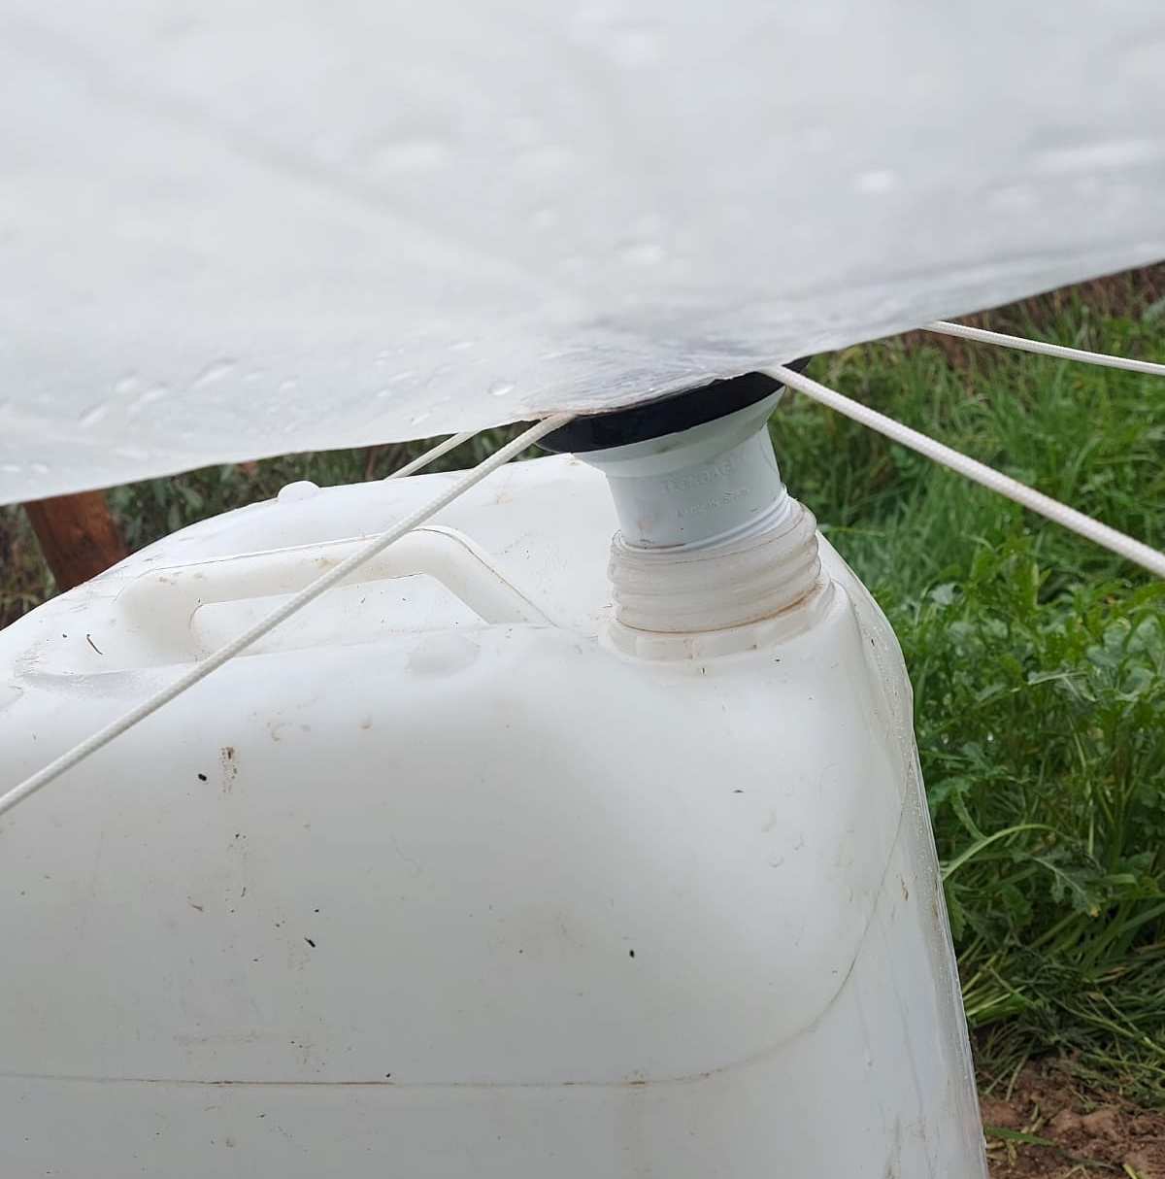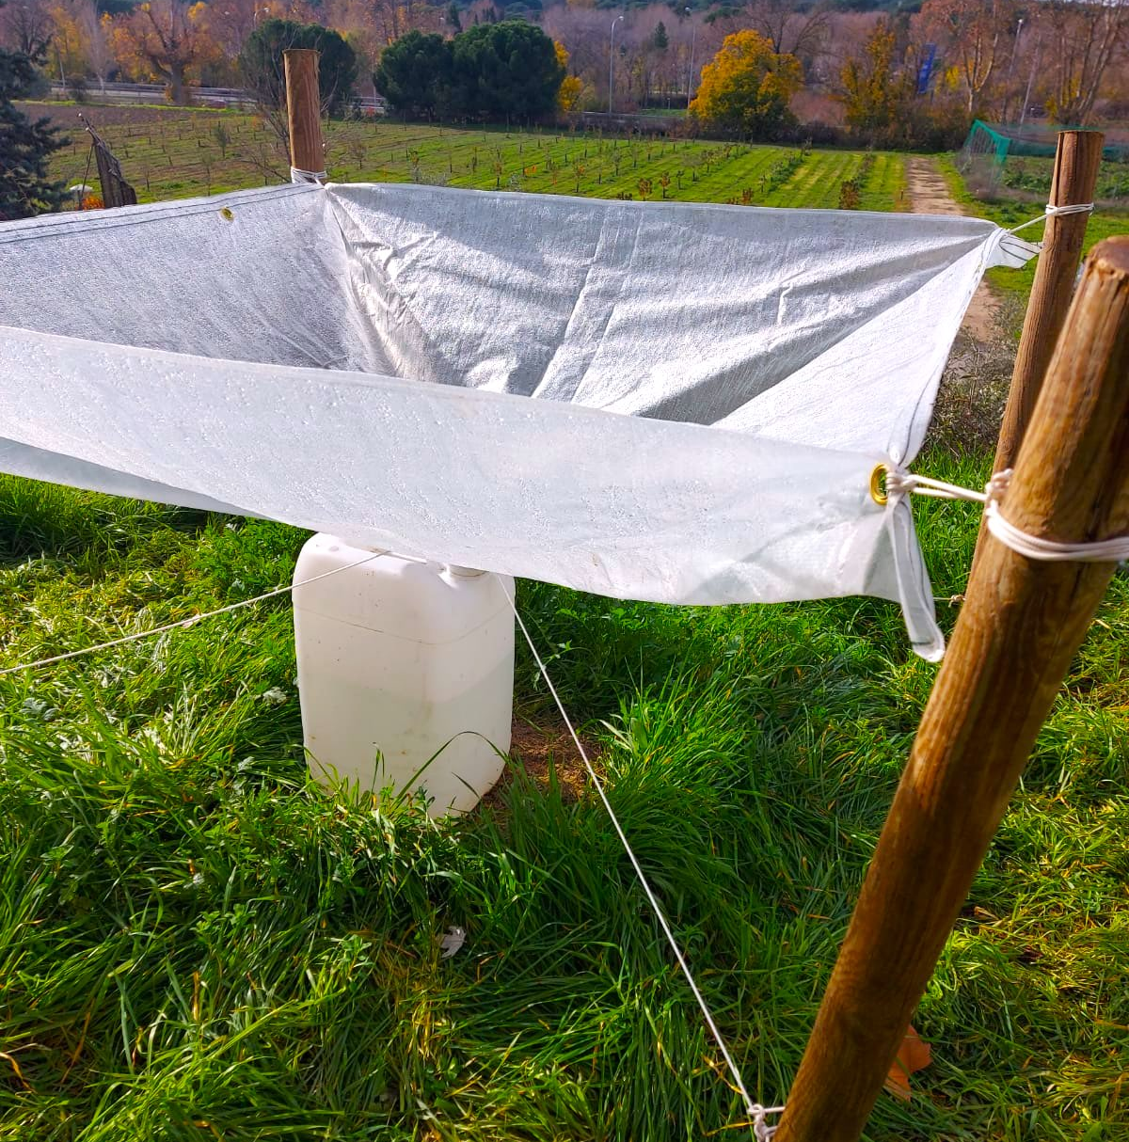
The drain is inserted directly into the tank.
4 WOODEN stakes are attached by tying them to the 4 EYELETS on the corners of the collector.
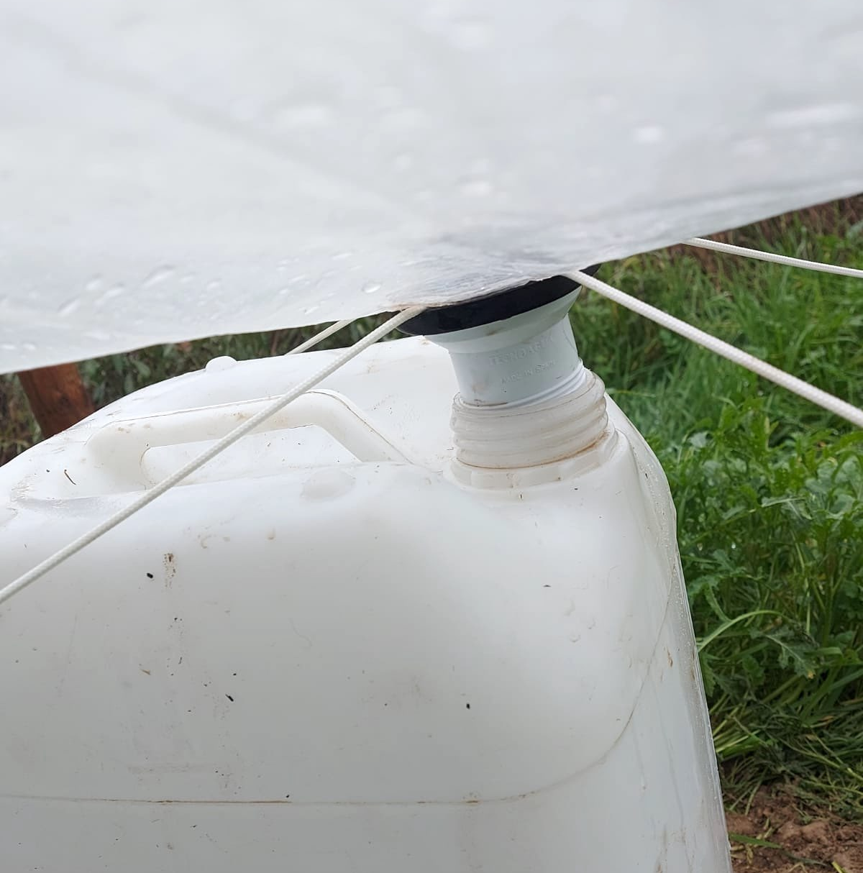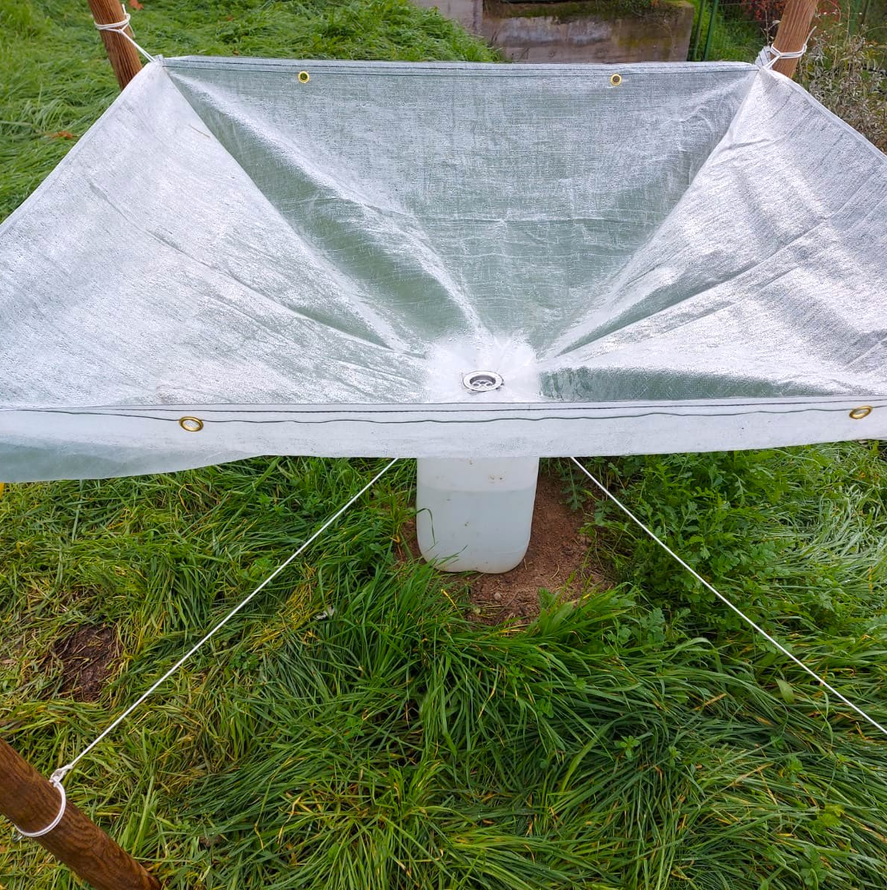
To reinforce against the wind, 2 ropes are pressed from above into the drain. Then, they are tied tightly to the 4 stakes.
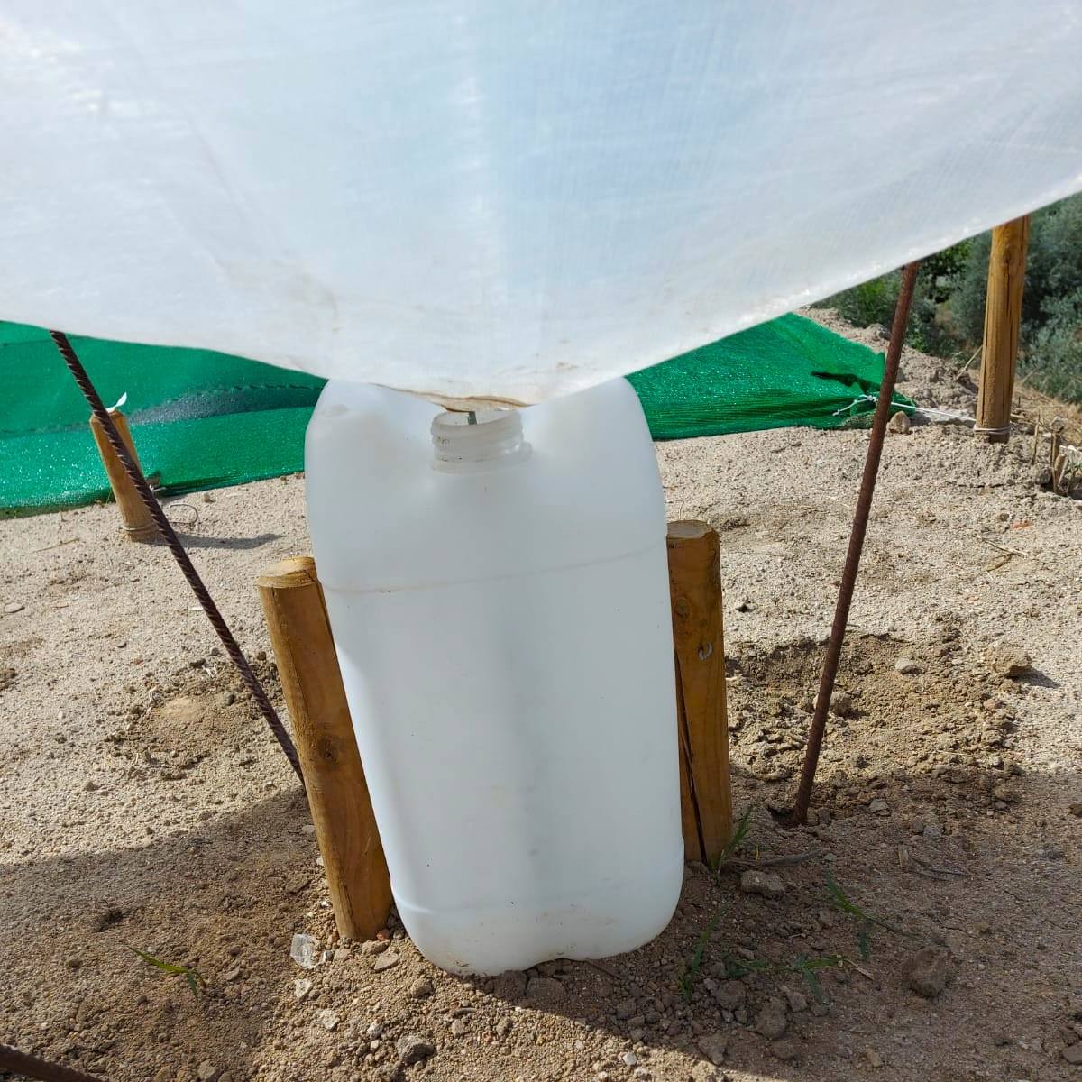
The tank can be secured with 2 stakes.

POTABILITY, CONSUMPTION AND CONSERVATION OF RAINWATER

Water is LIFE and it is "ALIVE". It requires CARE from the beginning.
Before drinking the water collected directly from the RAIN, you must PURIFY it by means of:

FILTERS
BOILING IT
CHLORINATING IT, if needed

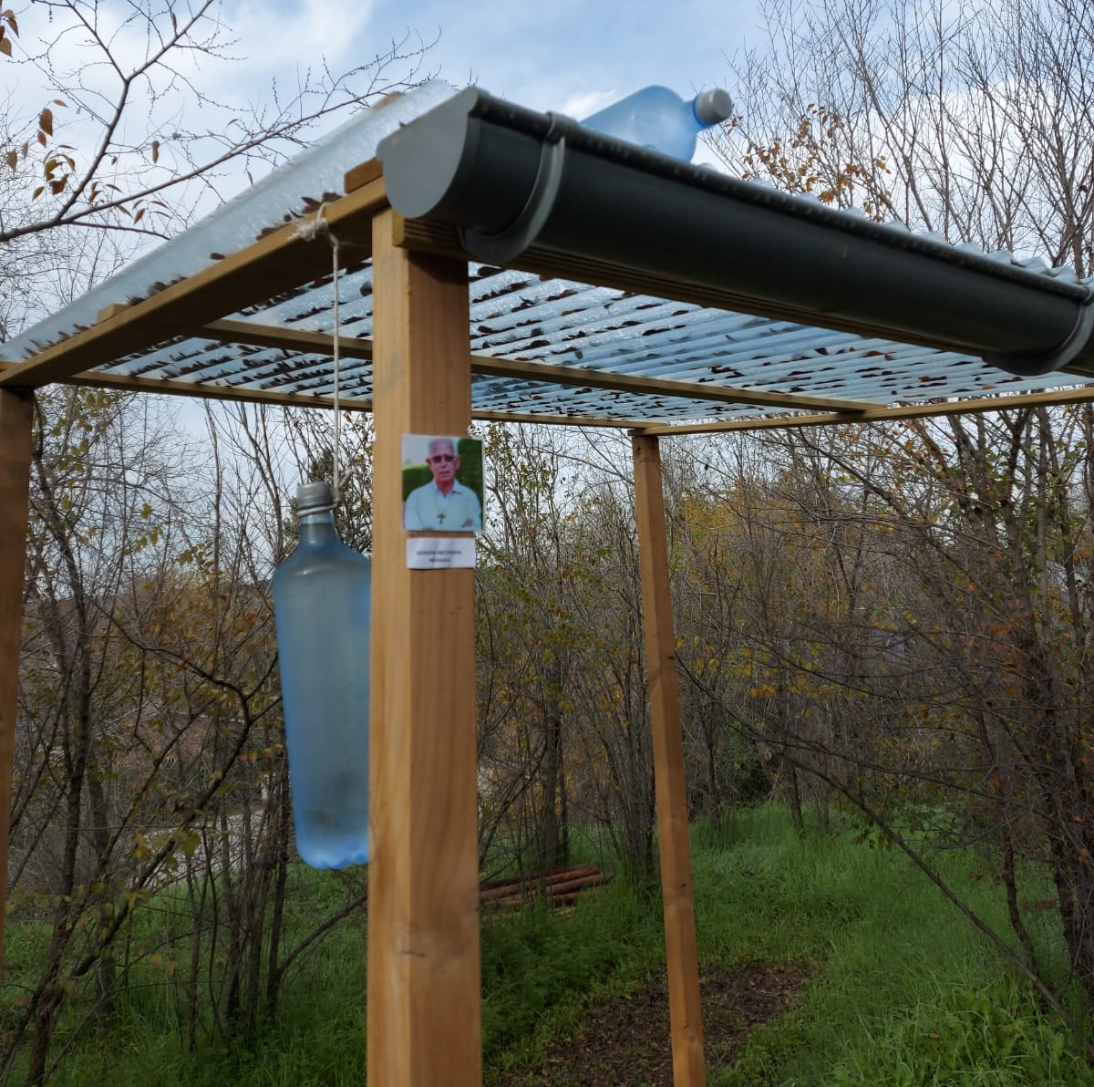
The SODIS method

The SODIS method of natural rainwater purification is simple.
It consists in putting TRANSPARENT PLASTIC BOTTLES in the SUN for:
8 hours if it is sunny or 2 days if it is cloudy.

In addition, we must be careful not to CONTAMINATE the water OURSELVES by:

- Guaranteeing the maximum personal hygiene by means of prior HAND WASHING.
- Using CLEAN pots. If possible, THE SAME.
- NOT MIXING water, even if it is clean, WITH CONTAMINATED FOOD.

OTHER IMPORTANT INFORMATION:

- The POND will always be built with LOCAL WORKFORCE and its installation will be preferably done by the interested parties themselves.
- It is necessary to BUY there:The auxiliary tank with a LID from which the water is taken out by the SIPHON system.
- The boiler to take out the water.
- Small wooden stakes.
- It’s also necessary to collect small stones to knot the MESH.

The KIT INCLUDES:

- The PLASTIC MATERIALS : FILM, GEOTEXTILE AND THE SHADE MESH
- Ropes, clamps and a stapler.

- IT DOES NOT HAVE, because it is OPTIONAL, THE INDUSTRIAL HAND PUMP.

