Model 1
Gutter FILTER SYSTEM and independent tank

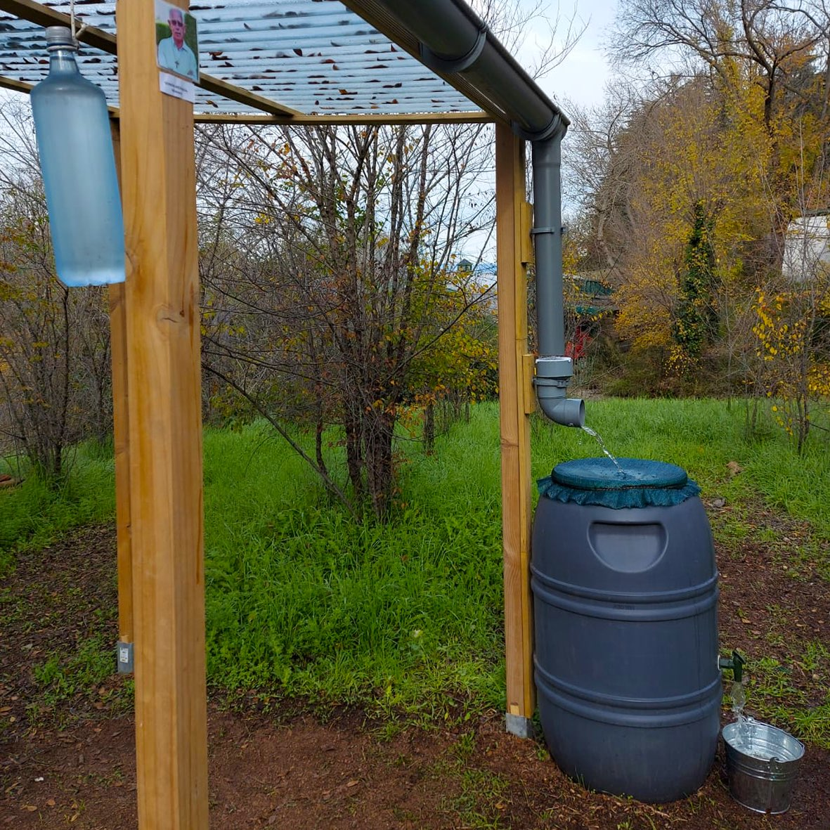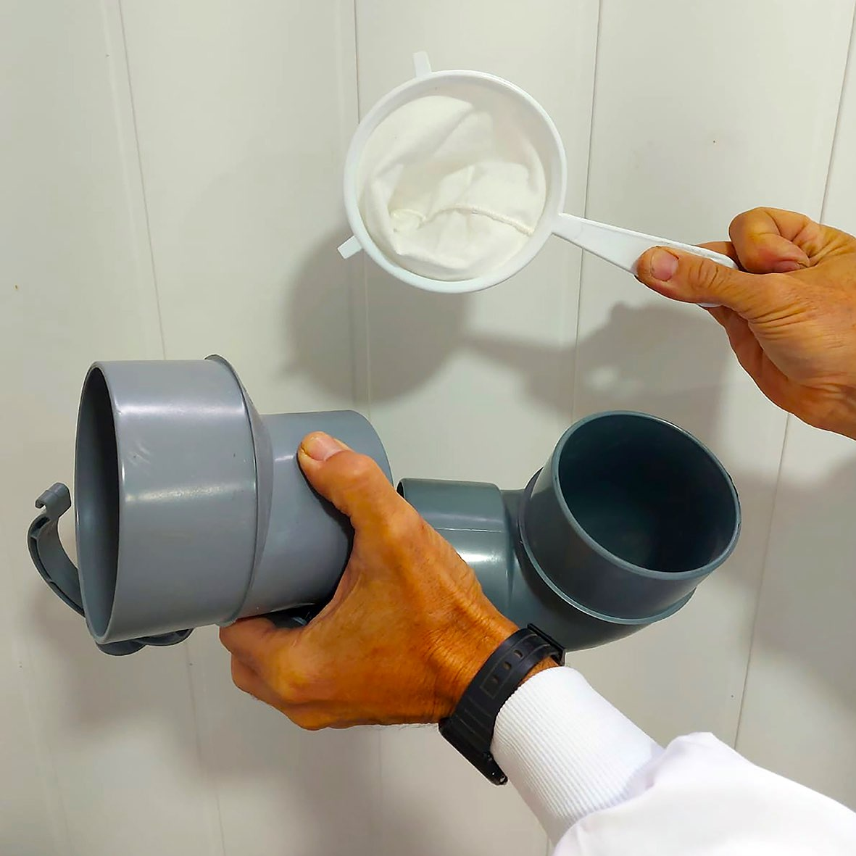
Any gutter with a downspout will do.
The new and very cheap thing is the FILTER SYSTEM.
It consists of four plastic elements.
The widest piece (1) that can be fitted with an elbow (2). A CLAMP (3) that is screwed to the wall and will be essential. And a fabric strainer (4) as wide as possible in the background.
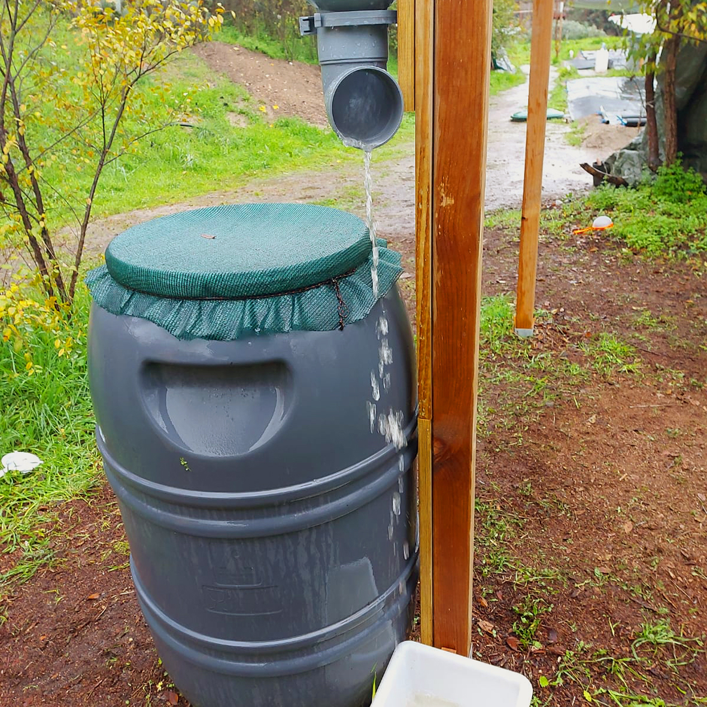
Filter: The CLAMP that is screwed to the wall, holds the SET of the two pieces together, PRESSING them but not IMMOBILIZING them. This allows a key 90º turn, enabling to pour the first dirty water.
When the water has already lost its dirt accumulated on the roof, turn the set 90º again and a fabric strainer will be applied.
Finally, from the tank with a TAP and a double mesh filter, the water will come out clean.

POTABILITY, CONSUMPTION AND CONSERVATION OF RAINWATER

Water is LIFE and it is "ALIVE". It requires CARE from the beginning.
Before drinking the water collected directly from the RAIN, you must PURIFY it by means of:
FILTERS
BOILING IT
CHLORINATING IT, if needed

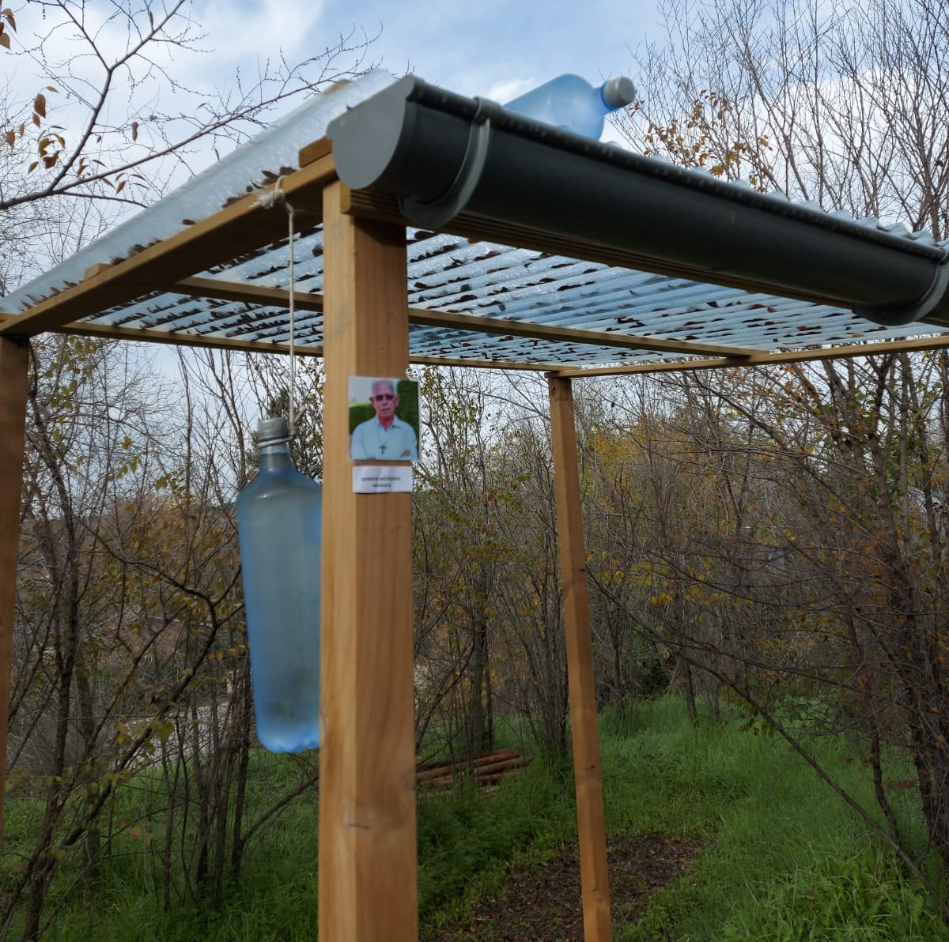
The SODIS method

The SODIS method of natural rainwater purification is simple.
It consists in putting TRANSPARENT PLASTIC BOTTLES in the SUN for:
8 hours if it is sunny or 2 days if it is cloudy.

In addition, we must be careful not to CONTAMINATE the water OURSELVES by:

- Guaranteeing the maximum personal hygiene by means of prior HAND WASHING.
- Using CLEAN pots. If possible, THE SAME.
- NOT MIXING water, even if it is clean, WITH CONTAMINATED FOOD.

OTHER IMPORTANT INFORMATION:
- The POND will always be built with LOCAL WORKFORCE and its installation will be preferably done by the interested parties themselves.
- It is necessary to INSTALL and BUY there:

- ASSEMBLE any type of GUTTER that collects water from the roof and its DOWNSPOUT to the tank.
- The tank with a TAP. A porous MESH and ANOTHER fabric to tie it covering the tank.
T h e m o d e l INCLUDES:
- The FILTER SET to put between the roof spout and the tank.
It consists of:
- A wide PART.1 An ELBOW. 2 Some CLAMPS (one is a spare). 1 DRAINER (p h o t o)

