Model 2

Expandable covered POND with auxiliary COVER-COLLECTORS

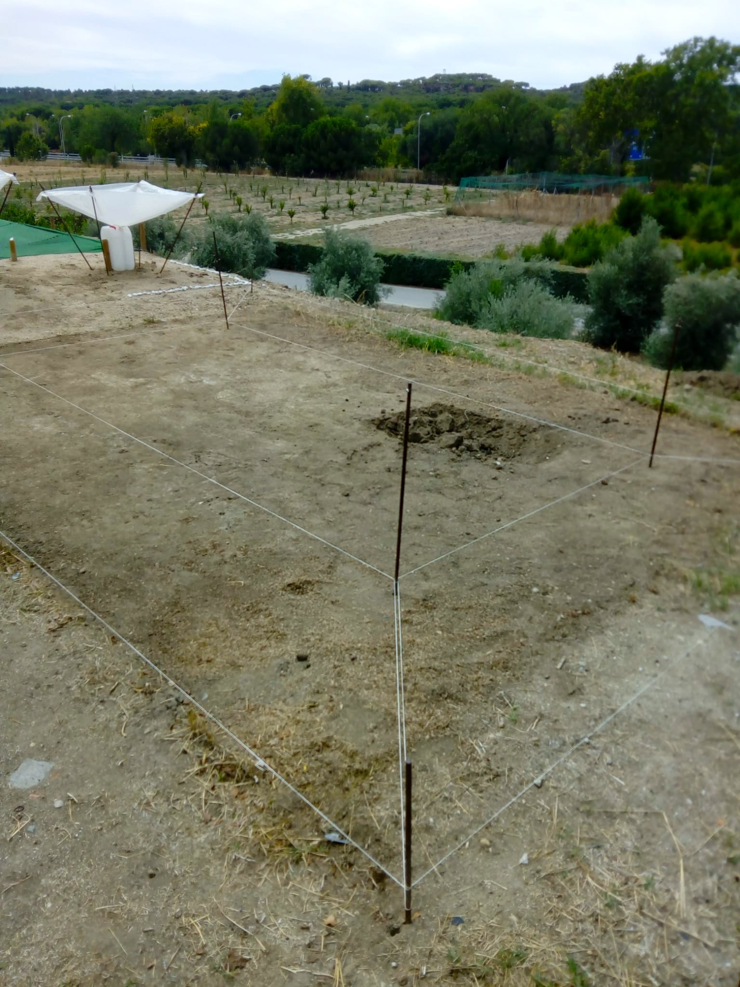 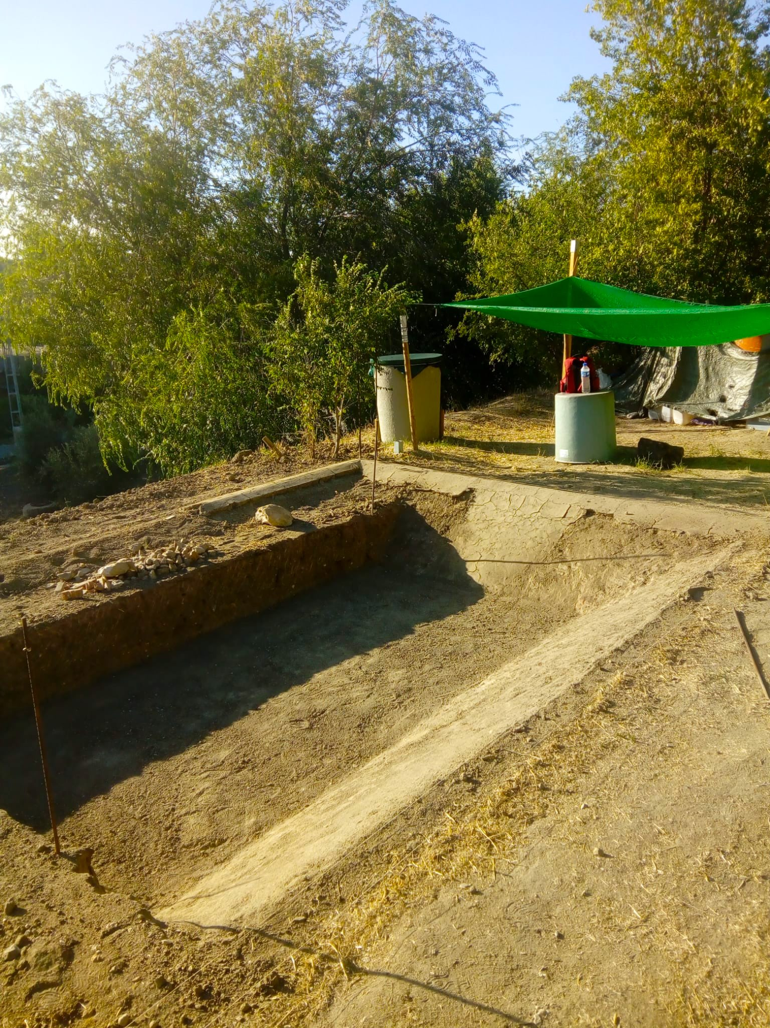

For its construction, at least 48m² of land, as flat as possible, is selected.

Both the 1-meter deep and the total area of excavation of the pond must be indicated.

SEE measurements and technical data AT THE END.

Once the meter of depth has been excavated, the surface of the bottom is extended by 1 meter PER SIDE, at an angle of 45°, until it reaches the height of the ground.

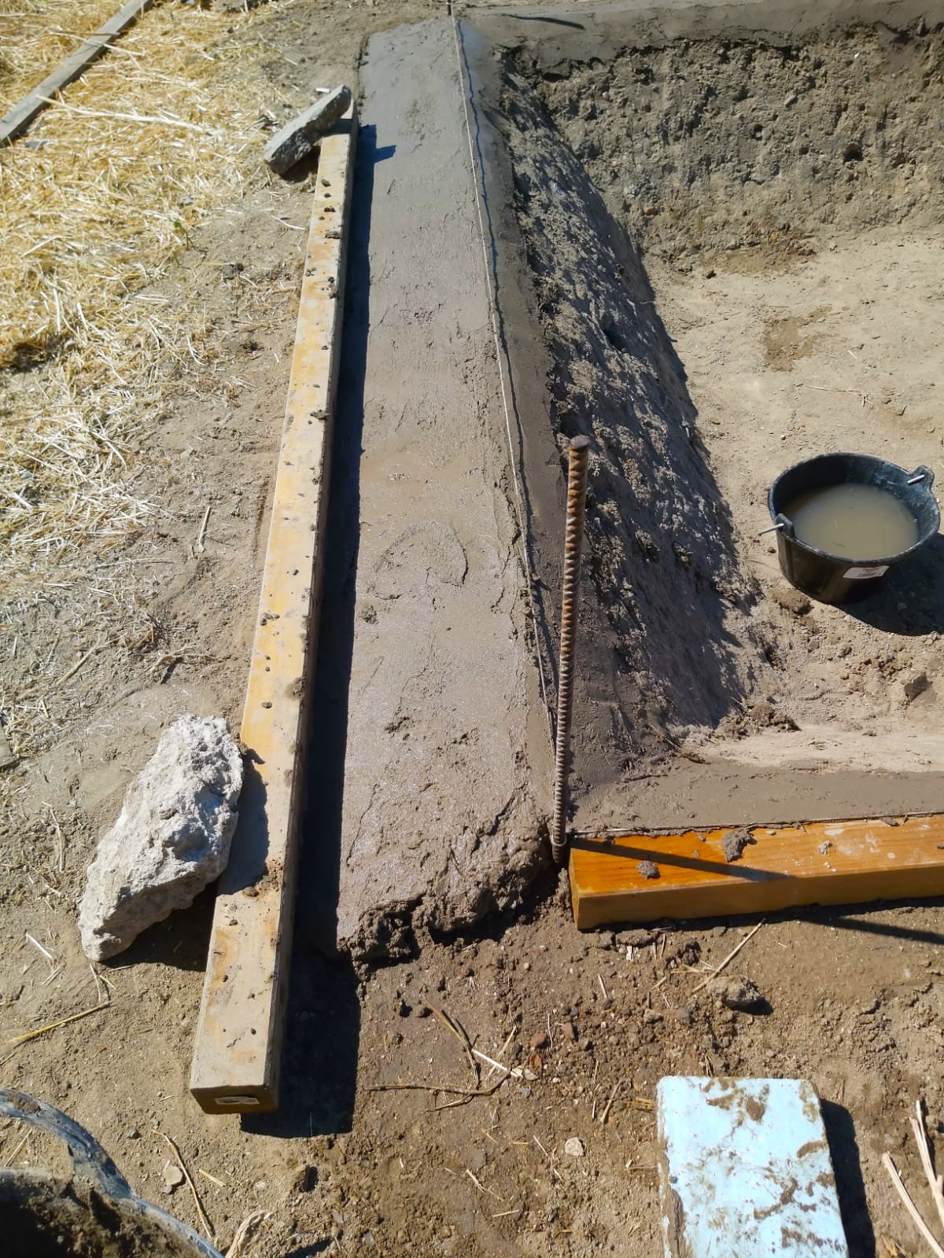 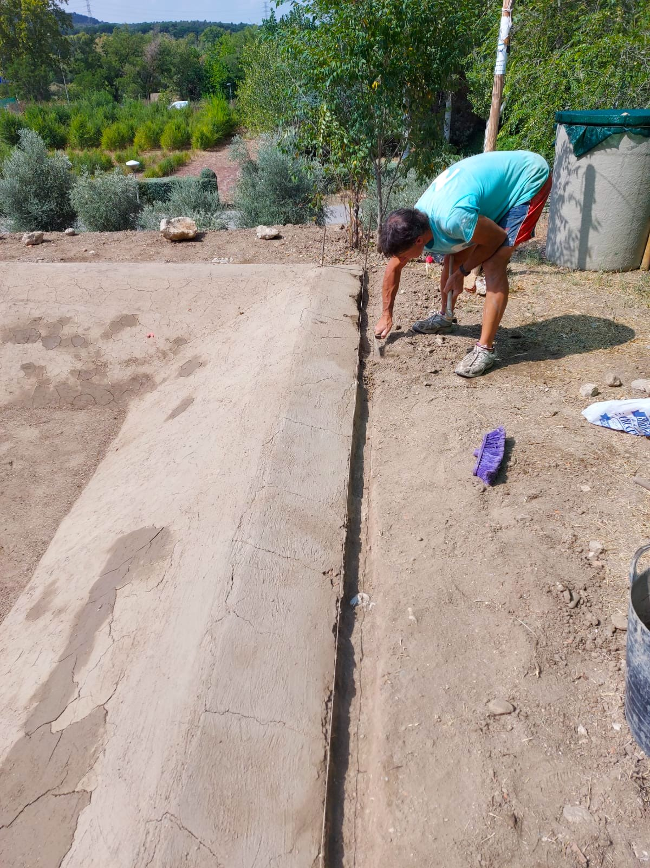

The four sides of the pond are raised by about 10 cm, with wet soil, to serve as a containment of muddy water from the rain.

Likewise, on all four sides, a slit is made through which the black FILM will be inserted and then tightened with wet soil.

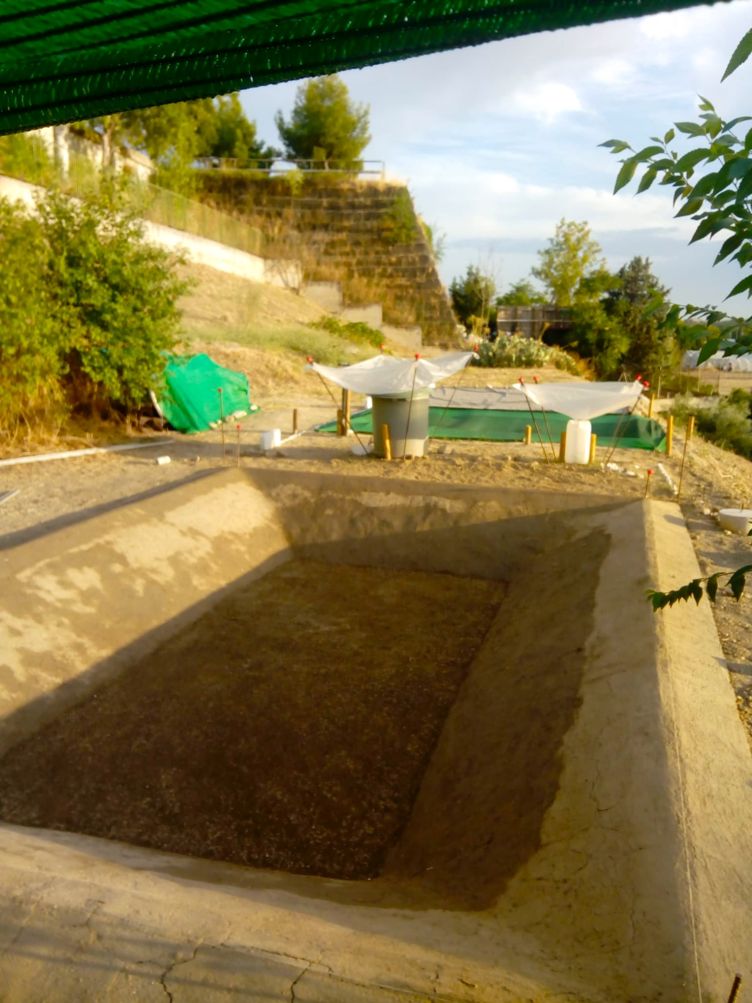 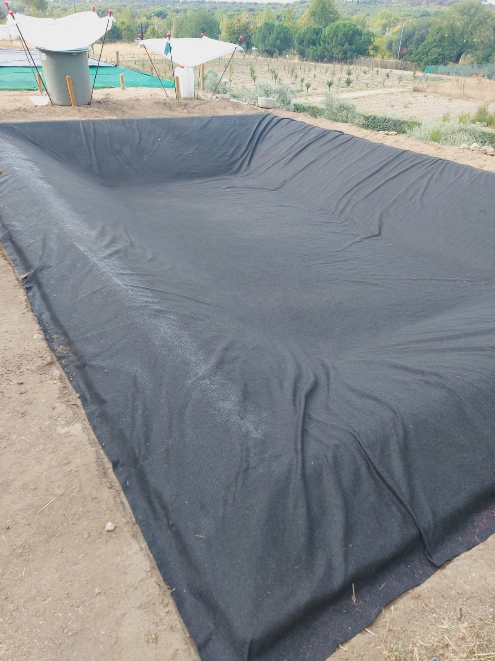

Once the pond is made, it is covered with a "geotextile" blanket that fits into the slits on the sides.

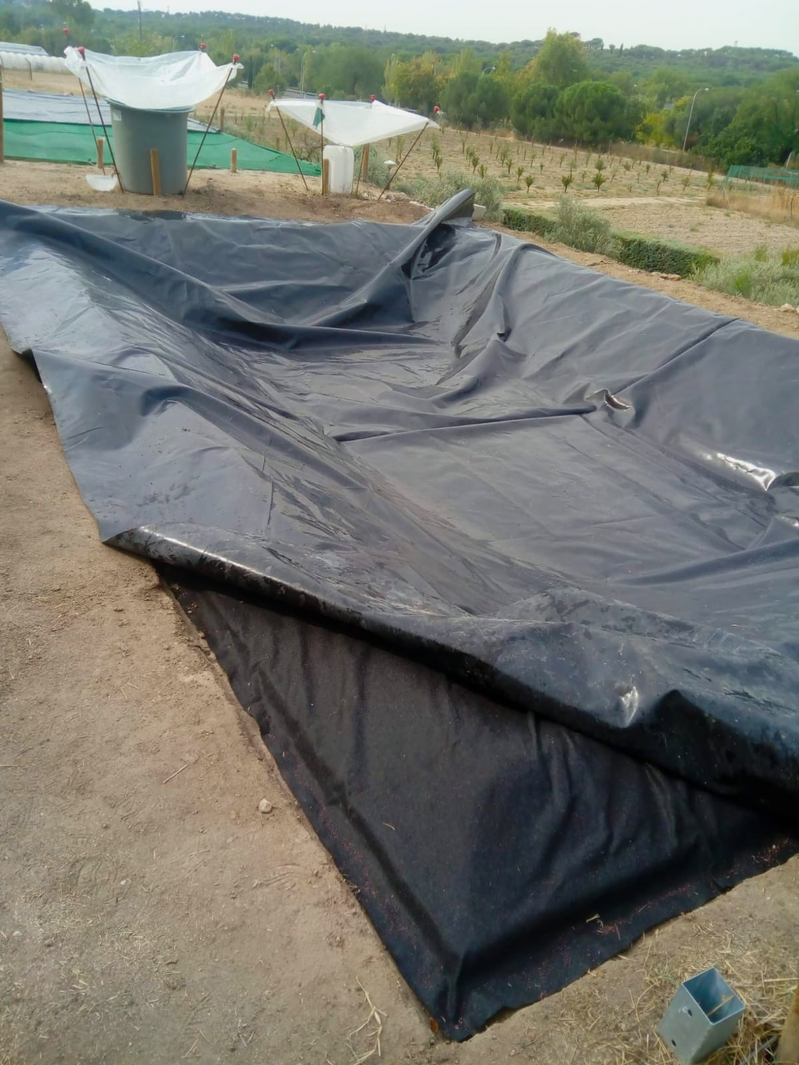 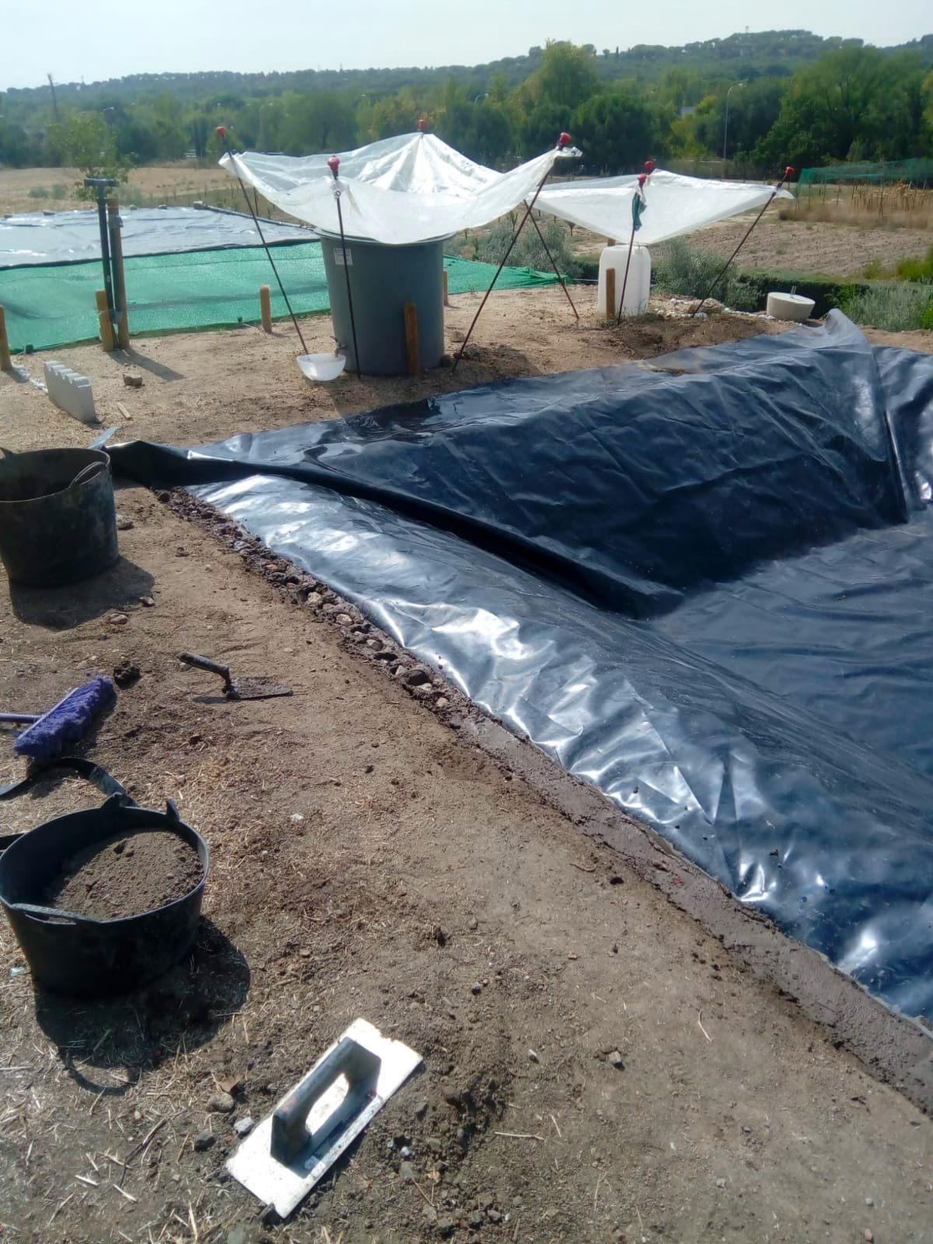

It is then covered with the black FILM, which is sealed to the floor through the crack with wet soil.

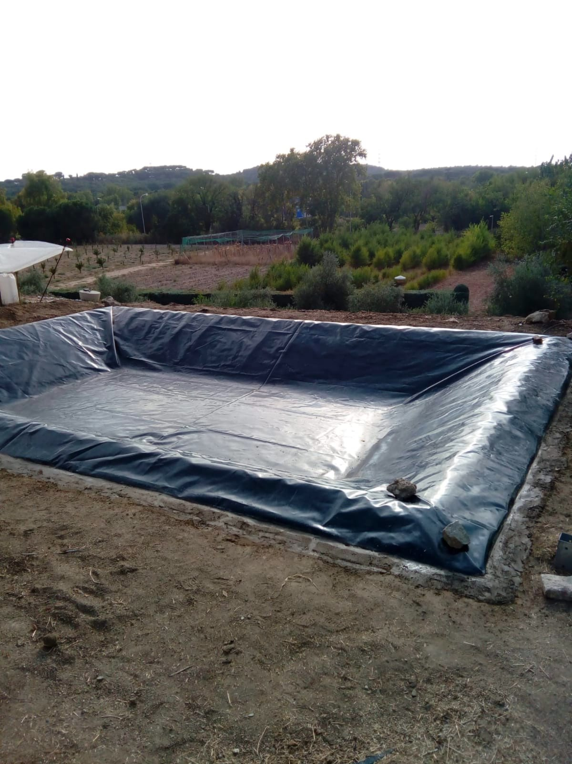 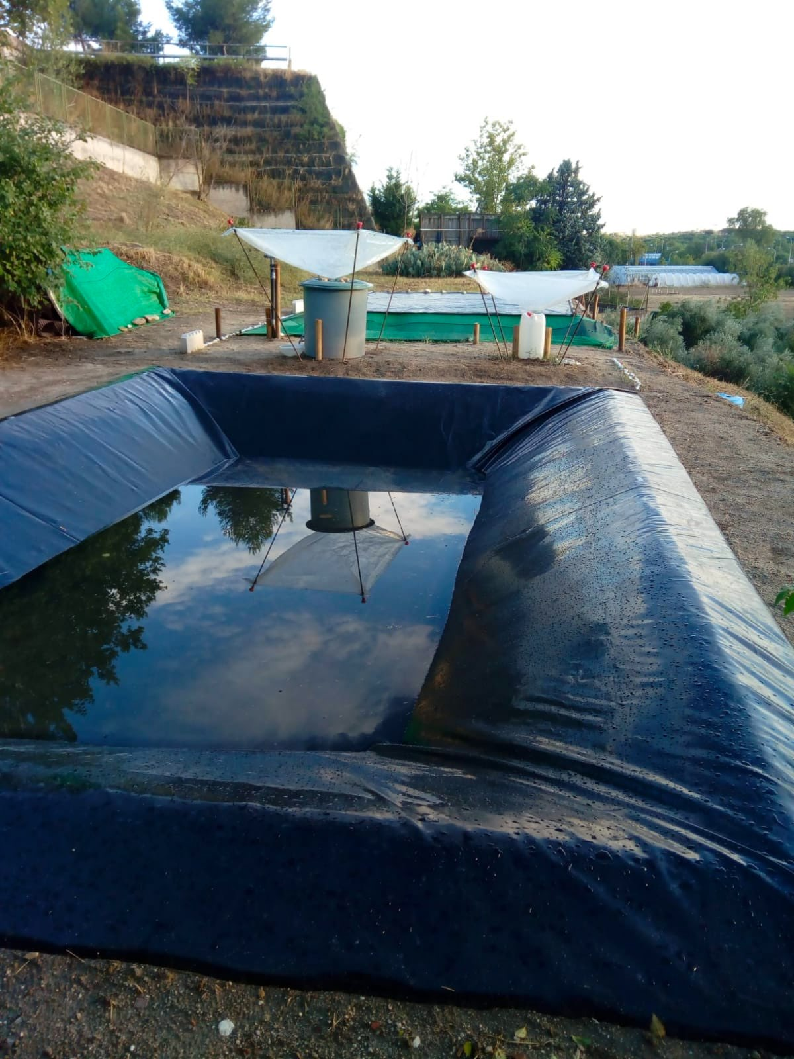

Finally, the pond is used to collect rainwater.